World of Peaceful People
Wholistic Sustainable and and Regenerative Life,
Vocational Learning, Self-Healing,
& Spiritual Center

About Us
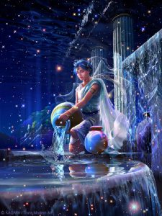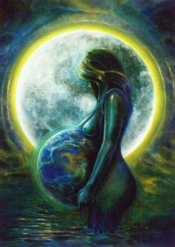
We are a committed, cooperative, and synergistic group of peaceful, sovereign, diverse, and unique people creating a donation-gift and membership based Sustainable and Regenerative Life Vocational Learning Center. A learning center that serves all ages, and cultures regardless of financial status, educational background, race, color, creed, culture, age, sex, sexuality, and religion or belief system. A Vocational Learning Center filled with people whose peaceful volition is with the sharing of knowledge that creates opportunity, and empowers those simply seeking to have for themselves, or their family, a better quality of life while becoming a positive and contributing influence upon their family, community, island, nation and world. A Vocational Learning, Self-Healing, & Spiritual Center complete with passionate, loving, dedicated, honorable, cooperative, committed and giving teachers, elders, masters, practitioners, and interns. These gifted mentors provide our students with the knowledge, skill, and experience to fulfill their passions in life while creating, and co-creating sustainable life processes, services and practices that benefit our members and all creation.
We are ‘out of the box’ thinkers, the ‘Get It’ generation, the ‘Children of the Dawn’ that believe in living our dreams, and passions, as we define our complete self, in the highest unified consciousness of shared values, morals, and principles, on the spiritual, intellectual, emotional, etherical, and physical planes of existence, as limitless beings.
The World of Peaceful-People’s volition is the creation of many, donation-gift based, associations and partnerships with other Sustainable and Regenerative Vocational Learning Centers, throughout the world, as we interact, share, connect, and contract with peaceful people and nations worldwide. Sustainable and Regenerative Life Centers sharing the knowledge, methods, tools, and skills needed to provide for themselves, and others. Knowledge and access to the basic necessities of life, inherent and unalienable to all people. These necessities are food, clothing, shelter, wellness, clean natural resources, and knowledge, to name a few.
Our Values are simple.
Discover and nurture the student(s) passion(s) in life as limitless creator(s).
Share with our students, and community, the value of honest communication, shared value, and the many ways to navigate through life.
Develop a strong foundation of interpersonal skills at the individual, group, team, and community levels.
Identify the most effective method of learning, or discovery, for each child, teen, and adult student, as there are many forms, ways, methods, and types.
Nurture the learning style of the individual, and group members, so success is achieved at one’s own pace. Success gained through leadership, self-direction, problem-solving skills, creativity, collaboration, innovation, partnerships, relationships, and service.
Create an atmosphere, environment, and vibration of pure love, and honor, as we do our part in serving the whole.
It is our positive, and loving volition that our programs lead to:
Synergy, cooperation, communion, higher values and morals, companionship, camaraderie, partnerships and personal commitment to self-empowerment as we share our knowledge, with all student members, of the various ways to create, or maintain, sustainable life sovereignty in a sustainable life world.
Environmental Consciousness: all student members are grounded in solution based limitless thinking in protecting our natural resources, and natural Eco-systems, as skilled caregivers and navigators of the Earth and the Universe.
Discovering environmental consciousness through regular contact with our natural surroundings and the connecting with other members to create solutions for environmental challenges to life sustainability.
Personalized Learning: Individualized learning, at one’s own pace, based on the learning techniques, or styles, of the student members to discover their passions, gifts, and where they wish to be of service, while honing their limitless creative skills.
Connecting, and networking, with peaceful people, groups, and members, from all nations, regarding the creation of similar sustainable life associations. Private Membership Associations honoring their cultures, in a shared value system, for sustainable life worldwide. Nations and cultures, each with their own representative, serving with the membership council of Integral Truth, Completeness, & Oneness creating methods of trade, bartering or exchange of cultural knowledge, values, travel, and natural medicines from each of our existing sustainable life communities, members, and partnerships.
Creating a network of donation-gift and membership-based learning centers working synergistically to end world poverty, hunger, homelessness, and war, to name a few, by creating model membership education centers that honor all cultures, in our global journey to peace and oneness in harmony with All That Is.

Mission Statement - World of Peaceful-Nations
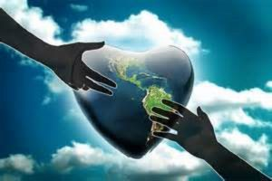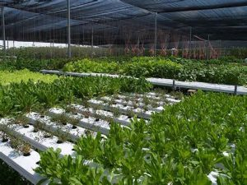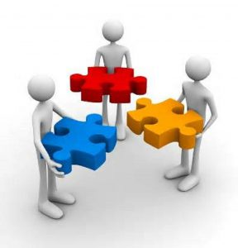
The World of Peaceful-People is a Private Membership Association. We are not a For-Profit corporation, or a Non-Profit corporation. We are co-creating a private membership association of trust, integrity, and honor through our individual membership programs, like-consciousness associations, and partnerships. Our mission is to honor the sovereignty of all nations, the individual sovereignty of the people, and all creation, while they live! The World of Peaceful People mission is simply a commitment to Wholistic Sustainable Life living in a peaceful harmonious world. We are a synergistic group of peaceful people and nations, created to serve and support each other in the evolution of our species, the Earth, the climate, our Eco-systems, and its effects upon all creation. We are sovereign sentient people and nations, living in the private, focused on solutions that bring an end to war and the separation among people, families, counties, communities, states, islands, countries, and nations.
We offer all our student members wholistic sustainable life practices and knowledge, along with the tools and the wherewithal for self-empowerment as they discover their individual autonomy, purpose, passion(s) and freedom, in their pursuit of personal and collective happiness. We offer learning opportunities, in many sustainable life practices, to fit our student members chosen field, or passion in life, so they may provide for themselves, or their family, a better life while being a positive contributing influence upon their family, community, island, nation, and world. We are a Vocational Learning, Self-Healing and Spiritual Center that provides the knowledge, methods, and skills needed to provide the basic necessities of life, inherent, and unalienable, to all people. These necessities being food, clothing, shelter, wellness, clean water, travel, and knowledge. A membership experience that takes the individual and collective members, regardless of age, on a sacred journey of knowledge in a world void of politics, control, separation, oppression, fear, doubt, ego, and limiting belief systems. Our vision is with members, other member associations and member nations of the world breaking bread, laughing, dancing, creating, praying, and playing together in synergy as gifted caregivers of this Earth. A membership council of committed peaceful people and nations creating solutions to world needs regarding education, poverty, homelessness, employment, spirit, wellness, climate, and world peace, to name a few. We are committed to protecting and honoring the Eco-systems, natural resources, values, morals, principles, culture, unalienable rights, natural rights, medical rights, human rights, religious and spiritual sustainable life rights, practices, teachings, and belief systems of our individual members and associations that we serve.
We are a shared-value Private Membership Association community of peaceful people providing options, and creating solutions, for each individual to discover their passion and gifts for securing a complete, and happy, life in spite of the circumstances they are, or may be experiencing.

Overview
Wholistic Sustainable and Regenerative Life Vocational Learning Center is a Private Membership Association that serves all ages, and cultures, regardless of their financial status, educational background, race, color, creed, sex, sexuality, and religion or belief system. A sacred geometry vessel created from integral truth, and compassion, to nourish the heart, mind, soul of our complete being. Centers of education and service that provide knowledge to those simply looking to have for themselves, or their family, a better life while being a positive, contributing influence upon their family, community, island, nation, and world. A World of Peaceful People consisting of passionate, loving, honorable, committed and giving mentors, teachers, ascending masters, practitioners, interns, and students, co-creating sustainable life processes to serve all. Complete individuals sharing collaboratively their love, and passion for life while honing their gifts to improve the quality of life for all creation of this Earth.
This is a shared-value learning center, of integrity, creating solutions for a world void of politics, ego, vanity, control, oppression, fear, doubt, indoctrination, and limiting belief systems. This Private Membership Association is creating a model for wholistic sustainable life living, worldwide. A Sustainable and Regenerative Life Vocational Learning Center that teaches the knowledge, methods, and skills needed to provide the basic necessities of life, inherent, and unalienable to all people. These basic necessities being food, clothing, shelter, wellness, clean water, travel, and knowledge. A symbiotic donation-gift and membership based educational experience that takes the individual, and the collective, on a sacred journey of knowledge that addresses world needs regarding education, employment, spirit, health, and world peace to name a few. We, at the World of Peaceful People, humbly and gratefully invite you to be a shared value member, group, association, or business sharing your presence, energy, knowledge, skills and resources at this Sustainable and Regenerative Life Vocational Learning Center. We supplement the needs to maintain a balance, harmonious, wholistic, and happy life through our various services at the learning, self-healing, and spiritual centers that work in synergistic flow, with each other, maximizing the benefits for our teachers, students, members, community, and island.
We commit to protecting and honoring the Eco-systems, natural resources, values, morals, principles, culture, spiritual, natural, unalienable, and sustainable life rights for our membership. Each host membership nation or association community will have a member representative to serve alongside other member nation representatives in co-creating trade/bartering systems; new sustainable life programs, student, member, and teacher exchange; international and intra-national safe travel programs. This allows all our members with an option, and an opportunity, to see the beauty of many, or all, nations of this Earth, without worrying about the cost of food, natural medicine, clean resources, shelter, and knowledge, to name a few.
Our Sustainable and Regenerative Life Vocational Learning Center is to be located on the island of Kauai. Kauai is located in the Hawaiian Islands, and also resides within the largest known nation, on record, Polynesia.

Natural & Alternative Birthing Center
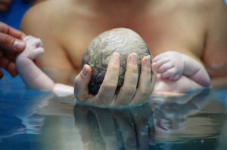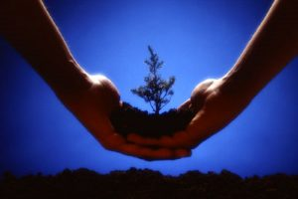
Our wholistic sustainable life journey begins at the Natural & Alternative Birthing Center, created in sacred geometry design. The gift of bringing a baby into the world is one of the most natural, and instinctive, acts that a woman's body is blessed to give. At the Natural Birthing Center, the participant members interact with skilled practitioners for education, support and the delivery services offered to the expectant mother, and her family. A center created for women who do not have the financial means for a traditional hospital delivery, or for those who simply wish to exercise their sovereign right to bring their children into the world in a natural, safe, and loving way. The birthing center also provides instruction, if needed, for first time mothers and their siblings, on the nurturing and care of infants.

Child Development Learning Center
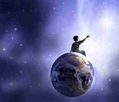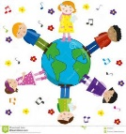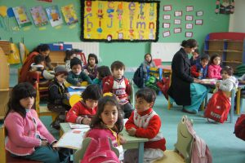
For the formative years, the wholistic sustainable life community offers a Child Development Learning Center. A donation-gift and membership-based knowledge center that offers our members various styles for learning; whether it be audio, visual, hands-on, kinesthetic, expressive, or simply to learn at one's own pace, to name a few. Our commitment and volition is that the child development center complements, or adds value, to other traditional, charter, or project-based learning schools, education centers and learning facilities.
Our skilled nurturing teachers, interns and practitioners observe, counsel, and cater to the learning style that best serves each individual child or student member. Our volition is that each student member, regardless of time, reaches their highest learning potential. Knowledge built upon a foundation of values, morals, and principles that serve all creation. An association community of limitless sovereign beings nurturing their passions in life that begins with the art of simply getting along. A wholistic social membership community that teaches interpersonal skills, conflict resolution, expressive art, problem solving, building relationships, and solution-based skills, as a foundation for the growth of the individual to be their true, authentic, limitless, and complete sovereign self. A nurturing environment where our members play, learn, eat, share, and meditate together as an extended, and loving, family. A nurturing environment where children learn various methods to properly steward the land, as they interact with nature, the universe, and all creation, in a loving creative way. Our Child Development Center is filled with instruments; books; art supplies; instructional toys and games; crayons; and an artistic canvas to draw and paint on. An environment for children to play and grow their imagination, in a positive, fun, and interactive environment as limitless, endless, autonomous, and sovereign sentient beings, of pure love, living in the private.
The child development membership center includes an organic, pesticide free, garden where the children plant, tend and harvest many different types of fruits, vegetables, flowers, and trees designed to feed and heal our members, the people of the community, other associations, and the island, as well as to beautify the land. The tools, used by our children, are child safe. The child development center offers programs, beyond farming, to serve the passion or needs of each member child. Children who might navigate or gravitate to other knowledge-based skills like the performing arts, healing arts, universal sciences. or other gifted modalities. There are limitless possibilities for our member children to learn, and grow, as our teachers discover each student's passion or passions in life. The collective member community encourages, inspires, and empowers all our member students to tap into their true, pure complete self, and their limitless potential. Our wholistic sustainable life member community offers an interactive environment, and the essential tools, for children and adults of all ages transform, heal, and empower themselves.
Our Private Membership Association education centers are to be gateways to fulfilling the needs and passions of our individual members, and collective dreams in harmony with All That Is.

Educational Day Care Center
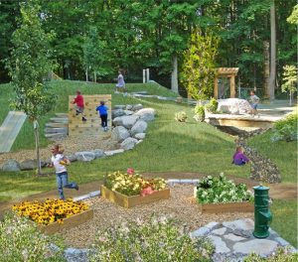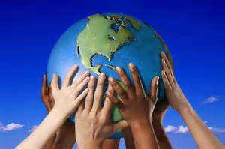
For single moms, or working parents, the wholistic sustainable life learning center offers an Educational Day Care Center to serve the needs of those families who cannot afford the cost of traditional day care. A Day Care Center of learning that is a nurturing, and safe, environment for their children. A center where a child can discover, create and pursue their passion(s) for living a sustainable nurturing life as an empowered and growing individual, or in a family unit. Day Care Children can participate in any of the programs currently offered or they can request a new program or application be added. It is our volition to fill that need with a qualified teacher, intern, mentor or tutor. Whether you started out as a single mom or from divorce, death, or a breakup, the tendency is to think of survival. Our wholistic community focuses on the basic needs of safety, food, clothing, shelter, natural medicine, good health, clean water and knowledge as your inherent rights to life as a human being. Our wholistic sustainable life learning centers empower you, and your loved ones, to embrace abundance with humility and gratitude.
We offer Parent Programs designed to teach the basic foundation of motherhood to those seeking knowledge, as first-time parents, in the areas of child-rearing. Our focus is with elevating one's self-esteem, confidence, and knowledge that we are here to serve each other, and fostering a complete and happy life, in spite of the circumstances we are, or may be, experiencing. Since we reflect our feelings, hidden or open, it is our knowing that if we are not happy, the chances are great that our children are not happy either. Our wholistic community honors the health and welfare of single parents, their children and others in need to discover their true joy and happiness.We offer Parent Programs designed to teach the basic foundation of motherhood to those seeking knowledge, as first-time parents, in the areas of child-rearing. Our focus is with elevating one's self-esteem, confidence, and knowledge that we are here to serve each other, and fostering a complete and happy life, in spite of the circumstances we are, or may be, experiencing. Since we reflect our feelings, hidden or open, it is our knowing that if we are not happy, the chances are great that our children are not happy either. Our wholistic community honors the health and welfare of single parents, their children and others in need of discovering their true joy and happiness.

Elder Care Center
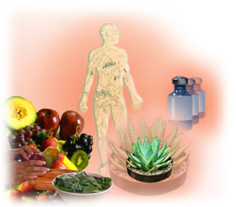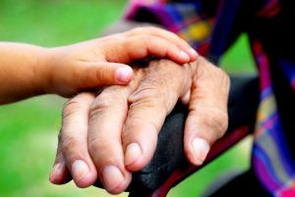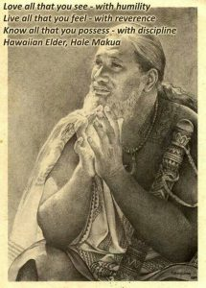
As younger healthy individuals, it is our responsibility to support the needs of our Elders. Good health, and healthy living, is the sovereign right of every individual. The Elder members of our society play an important role in wholistic sustainable life. At our Elder Care Center, we offer programs needed to maintain quality of life. Our passionate teachers, mentors, practitioners, students and interns strive to understand the elder individual, by observing and recognizing their uniqueness, in order to create a quality-of-life environment for their waning years. Our Elders need a sense of purpose and belonging, throughout their lives, and it is important to nurture and maintain their self-esteem. Working closely with our elder community, we have the opportunity to learn from their experiences, and embrace their wisdom. We honor each person's right to make knowledgeable personal choices regarding their care. We offer a shared value learning and nurturing environment, for our elder community, consisting of children, animals, peers and teachers to assist them in their continued care, growth, and self-esteem even when faced with debilitating health issues.

Natural Self-Healing & Alternative Medicine Center
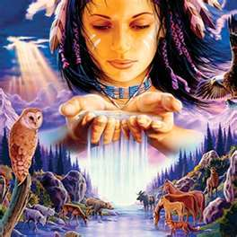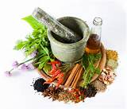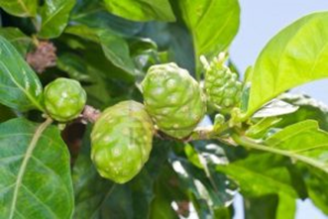
Our wholistic community supports the inherent right to the good health of all people by providing natural health services, at our Wholistic Sustainable Life Self-Healing Center. Our learning focus is improving a persons’ overall health, which naturally improves one’s quality of life. We implement many styles of cultural, natural self-healing modalities and wellness alternatives that best serve those who are in need. Our donation-based Wholistic Self-Healing Center offers natural, alternative and wholistic services that are not currently available, or accessible, to the people due to the lack of insurance, personal finances, or for other personal reasons. Our dedicated research team of teachers, visionaries, practitioners, and students serve to improve the health and welfare of all creation. We offer education, training, and knowledge in a variety of natural and non-invasive services in our self-healing, or therapy, sessions. Services and educational programs like Reiki, Energy, Sound, Color, Reflexology, Cranial and body Massage, etc.
Our Wholistic Self-Healing Center, and other structures, is handicap accessible. The focus is the implementation of user-friendly methods that support the functional needs, for the quality of life living, of all handicapped students, members, residents, teachers, and their families.

Agricultural Learning Center – Organic
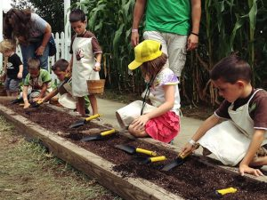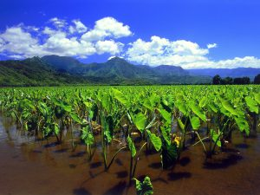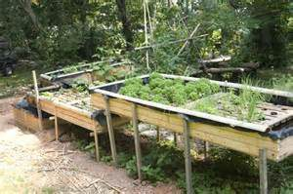
The Organic Agricultural Learning Center offers all students, regardless of age, an understanding and solid foundation in the art of pesticide free organic farming. We offer various programs, and methods of organic farming like Permaculture, Aquaponics, Mixed Crops, Subsistence Commercial, Sedentary, Vertical, and the creation of fish ponds, to name a few, to meet various food needs. We share our knowledge of organic system interactions like crop rotations, soil and nutrients, cover crops, water use needs, and pest and disease management. We share the knowledge and methods used to increase soil fertility and organic matter, increase soil biodiversity and microbial activity, prevent erosion and runoff, protect or improve water quality, attract beneficial insects, and improve soil structure.
Whether the purpose is for single family, multi-family, or community based farming, our skilled teachers share their knowledge, and skills needed for growth, maintenance, and harvesting of the plantings. The knowledge offered here is beyond food production. We teach the identification of the medicinal parts, of fruit and vegetables, as sources of healing. Our agricultural center, and organic gardens, offer healthy and balance food alternatives to maintain and nourish a healthy you. Our gardens and orchards produce pesticide free, organic food for those in need throughout the island. If needed, we utilize the skills and resources of our worldwide member network of wholistic sustainable life communities, interested third parties, local government, and others. These third party, or existing resources, acts as a vehicle to assist individuals who may need equipment to simply till the soil, plant, and prune or harvest their products. As an extension to the Agricultural Center, we offer programs in food preparation at our Culinary Arts Center. Our Agricultural Center is about sharing the knowledge of seed to store processing, and the protection of our natural Eco-systems in a pesticide free world.

Farmer's Market
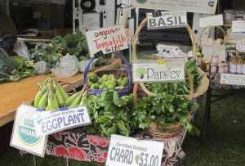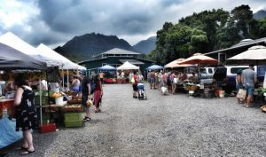
Each week a Farmer's Market is held to support the continuing education and needs of our students, teachers, community, and the island. The farmers market is open to all community and non-community, organic farmers to barter and trade, or to market their products and services, to tourists, businesses for-profit and non-profit organizations or corporations or companies.

Culinary Arts Center
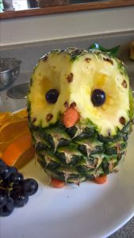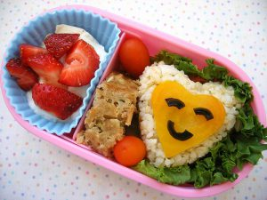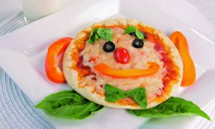
The Culinary Arts Center maintains a beautiful, clean, Eco-friendly kitchen with the proper tools and equipment needed to prepare large amounts of natural organic, life-affirming health foods and beverages. Here, we share, offer and teach our knowledge of safe and effective food processing, packaging, storage, meal preparation, and various methods of cooking, preservation and the serving of natural organic life-sustaining foods. A method to maintain the maximum shelf life, of the harvests, using nature's natural gifts of preservation. A soup kitchen is available and our student's will deliver food to those in need, who may lack the means to visit our main, satellite, or wholistic sustainable life distribution centers.

Sewing, Weaving & Craft Center
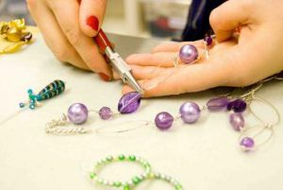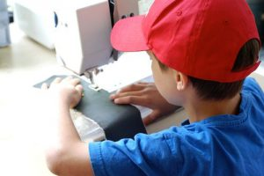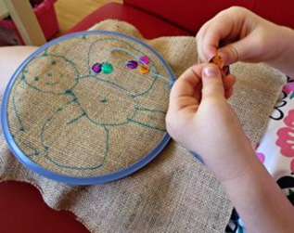
To support the basic necessity of life for clothing, we offer a Sewing, Weaving and Craft Center. Here, we share our knowledge and experience in the art of clothes making and design, using traditional and non-traditional methods. Our clothes and other items are made from hemp and other Eco-friendly materials. This center teaches environmental conscious crafts, or services, like feng shui, ergonomics, or other methods of fit, form and functional designs that enhance the fashion, or the beauty of us, our home, or our personal sacred space. We also offer the art of jewelry making, & design, utilizing shells, gems, or other materials. In supporting the needs of our cultural or performing art centers, our craft students create props or various instruments need to support our community or public performances, shows, and other themed events.

Veterinary Learning Center
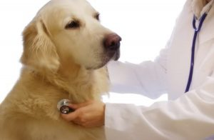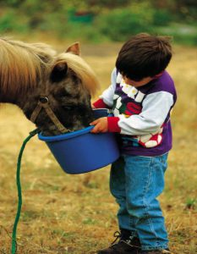
For those seeking the art of animal care, it can be found at our sacred geometry Veterinary Learning Center. At the Veterinary Learning Center, our teachers, interns, practitioners and students share their knowledge, spirit and love in the care and nurturing of abused or abandoned animals.
Our wholistic volition is to assist and heal our animals, in their return to a normal, healthy life with a loving, nurturing family, and environment. At our wholistic sustainable life communities, the animals are treated with the same love and honor as our teachers, practitioners, students, volunteers, and participants. At this center, we learn to speak each other's language verbally and telepathically, as we engage the animals in providing us with nourishment, healing and playfulness or to simply reflect their beauty, as partners of creation.

Landscaping Center
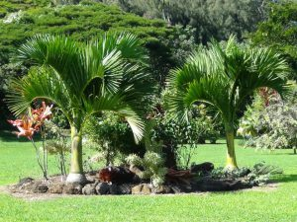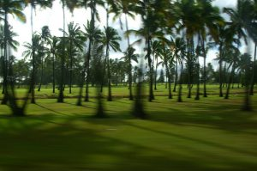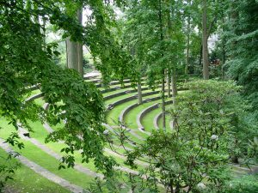
At the Landscape Center we teach our students, interns, and staff proper native plant selection, plant identification, plant spacing, proper mulching, soil moisture, irrigation, energy efficient use of trees or shrubs, grafting, testing soil PH, water resources and conservation, Eco-friendly green practices, composting and recycling practices.

Performing Arts & Edutainment Center
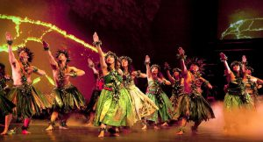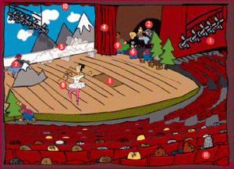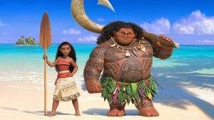
The Performing Arts and Edutainment Center is the place to entertain, and educate our students interested in pursuing their passion through the arts. A center for learning, developing, or expressing one’s art through song, dance, poetry, visual arts, martial arts, technological art, oils, various instruments, or other forms of artistic expression that expands the knowledge of our senses and our students. We tap into the students’ creative ability to create music, and interpret sounds, which is dependent upon our body's capacity to mechanically interpret wave patterns, not through quantitative differences but proportional differences as well. All our bodily senses work because our nerve receptors are able to attune to variations in proportion of input frequencies. Even our sense of smell relies on our ability to interpret the geometric construction, rather than the molecular substance of an odor. Our visual sense differs from our sense of touch only because the nerves of the retina are not tuned to the same range of frequencies as the nerves embedded in our skin.
Our sense of proportion tells us when a space or object is harmonious, and our mood responds accordingly. Just as we identify sounds as being pleasant, or otherwise, as a result of their wave frequencies and the proportional relationships between combinations of different notes. It is our spatial awareness that connects, or repels, us with items that we normally perceive to be remote and external to us. At our performing arts center, we provide an educational format for learning and understanding our complete self through the arts.

Sacred Geometry Amphitheater
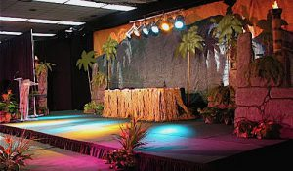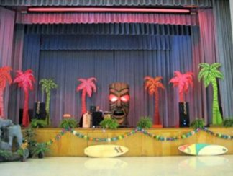
When it comes to performing arts, our students will offer various donation-based programs to the public at our Sacred Geometry Amphitheater. Students of all ages entertain us with their music, dance, plays, etc., on the main stage, or at our children's theater pending the type of performance or program needs. The children's theater, and stage, is created by the children participating in the performing arts, and structural design programs.

Universal Science Center
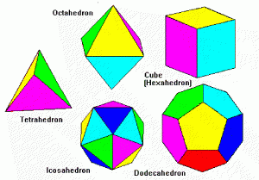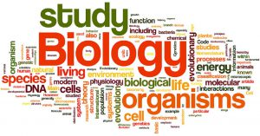
Universal Science Center
At our Wholistic Sustainable Life Universal Science Center we share the knowledge of various sacred sites around the world, and their association in regards to longitude, latitudes and ley lines. We offer programs in:
Physical Sciences
Physics: The study of matter and energy and the interactions between them.
Chemistry: The science relating to composition, properties, reactions, & structure of matter.
Astronomy: The study of the universe beyond the Earth's atmosphere.
Earth Sciences
Geology: The science of the origin, history, and structure of the Earth.
Oceanography: The exploration and study of the ocean and its’ inhabitants.
Paleontology: The science of the forms of life that existed in geologic periods.
Meteorology: The science of the atmosphere, weather & climate change.
Life Sciences (Biology)
Botany: The study of plants - Natural and Wholistic qualities.
Zoology: The science that covers animals and animal life.
Genetics: The study of heredity.
Mathematics of Life
Arithmetic - Addition, subtraction, multiplication, and division as a foundation.
Algebra - Arithmetic process where letters representing numbers are combined.
Golden Ratio - Create a sense of beauty & knowledge through harmony & proportion.
Solfeggio Tones - Secret meanings of the ancient syllables
Fibonacci Sequence - A mathematical sequence of combining numbers
Sacred Geometry - The key and the means to render visible that which is concealed from the undiscerning and untrained eye, and that these fundamental geometric relations, manifested through form, pattern and number, form the very basis of harmony.
French architect Paul Jacques Grillo, who wrote, “The world around us is a world of numbers―numbers that spell life and harmony. They are organized by the geometry of figures, all related to one another according to a sublime order, into dynamic symmetry. Glimpses into this magnificent kingdom form the basis of all our knowledge and it seems that in this domain the ancient civilizations had gone further than modern science. ”
It is our volition to expose our participants to the most useful forms of math and geometry found in everyday life and to help discover their limitless potential.

Cultural Arts Center
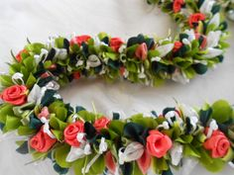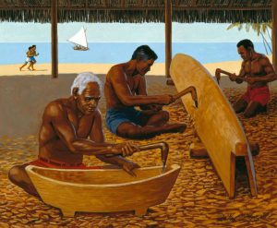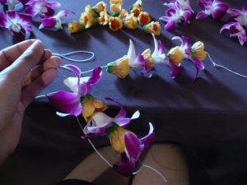
The Hawaiian/Polynesian Cultural Arts Center is the foundation of our Wholistic Sustainable Life Learning, Self-Healing and Spiritual Center located on the island of Kauai. Our volition is to honor the cultural and spiritual practitioners and their practices that preserve and protect their rights, knowledge, wisdom and experience regarding the use of the land, its’ natural resources, and the proper usage of its’ natural medicines. Here, and at our Organic Sustainable Life Agriculture Center, we share the knowledge, history, methods and traditions of growing healthy sustainable foods, and their preparation from seed to store.
At this Cultural center, Hawaiian language, drumming, ukulele, hula, storytelling and other facets of Hawaiian culture are offered.
Also offered is the ability to learn non-instrument navigation using the sun, moon, stars, stones, and waves as an extension to our Universal Science Center.
There are classes in the traditional art of canoe building. A tradition that requires prayer, and foods, being offered to the forest gods, as an act, before, during, and after the tree, used in canoe construction, is taken from the forest. In an effort to support and honor other cultural modalities, we connect with other cultural programs and organizations throughout the islands.
Field trips to sacred sites, and heiau's to perform cultural and spiritual rights, gathering, maintenance, and to learn their meanings, stories and the spiritual significance of each site is offered.
This center teaches cultural healing arts of the mind, body and emotions and is a cultural extension to our primary Self-Healing Center. We offer programs in the Hawaiian martial arts of self-defense. We also offer programs on how to make musical instruments, tools, or other useful products, from various woods, or materials, indigenous to the area.
In addition, we offer Hawaiian food preparation, cultural meals and other culinary skills in concert with our Culinary Arts Center.
Many topics are offered to support the further understanding of the Hawaiian people, their culture, history, and their current, or long-standing, sustainable life practices.
We visualize all our centers as creators of abundance! There are classes in the traditional art of canoe building. A tradition that requires prayer, and foods, being offered to the forest gods, as an act, before, during, and after the tree, used in canoe construction, is taken from the forest. In an effort to support and honor other cultural modalities, we connect with other cultural programs and organizations throughout the islands.
This center teaches cultural self-healing arts of the mind, body, spirit and emotions that is a cultural extension of our Self-Healing Center. We offer programs in the Hawaiian martial arts of self-defense. We also offer programs on how to make musical instruments, tools, or other useful products, from various woods, or materials, indigenous to the area.
We offer Hawaiian food preparation, cultural meals and other culinary skills in concert with our Culinary Arts Center. Educational field trips to sacred sites, and heiau's to perform cultural and spiritual rights, gathering, and to learn their meanings, stories and the spiritual significance of each site is also offered.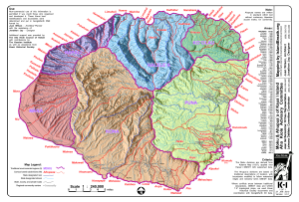 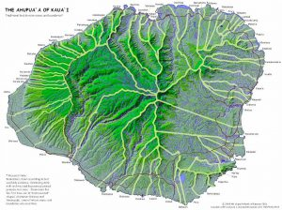

Language Arts Center
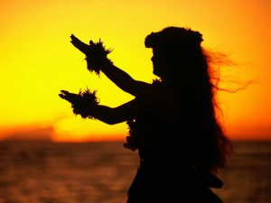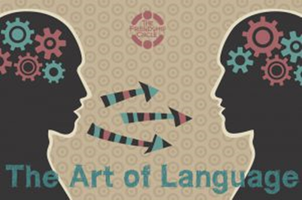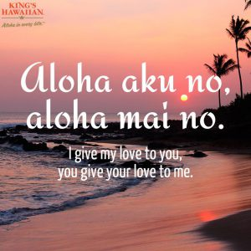
Our Language Center offers Cultural, and other languages, as a gateway to honest communication locally and worldwide. At our main center, in Kauai, we offer the Hawaiian Language, as the primary language, and English as a second language. Other languages are offered as needed and available.
As part of the language course, instruction is given regarding day-to-day interactions and the chants, terminology, expressions and common phrases used as a foundation for a language of Aloha, culture, rituals and spiritual practices. Also, we teach greetings, introductions, symbolism, pronunciation, vocabulary, and the history and meaning behind words, laws or phrases like Aloha, a hui ho, Hau`oli La Hanau, Aloha Spirit Law, fishponds, aina, iwi, wai, ahi, aquifers, ahupua`a, kuleana, agriculture, crown lands, moku, kahuna, konohiki rights, pule, Ali’i, cultural & spiritual rights, Mokupuni, Ala Loa trails, and the existence of the sovereign Hawaiian Kingdom, to name a few.
It is our volition for our students to communicate, write, read, and have cultural understanding of the Hawaiian language and have a symbiotic relationship with the Cultural Arts Center
Students are also offered factual communication using Correct-Sentence-Structure-Communication-Parse-Syntax-Grammar. The volition is with the expanding of our gifts with speaking factually and simply, or telepathically. Our students and teachers are co-creating a new dictionary, or light language, of signs, symbols, words, forms, numbers, and other positive methods to bridge communication gaps, as needed.
It is the volition, of the Cultural Language Center and the Sanctuary of Truth, Completeness, & Oneness to co-create a set of values and morals that will serve all creation trough honest communication and integrity.
These creations act as a Unity Compass to navigate our individual, and collective passions for wholistic sustainable life, and our symbiotic relationships with all creation in a cooperative, committed, peaceful, loving, and communicative way.

Alternative Energy Center
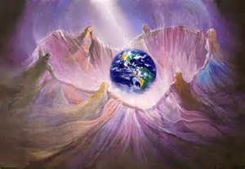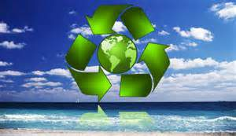
Our Alternative Energy Center offers instruction, knowledge and experience regarding the installation and maintenance of various energy alternatives. We teach the process or concepts of Hydro-electricity that captures energy from falling water; Wind as the generator of electricity; Tesla technology; solar energy from sunlight; or light being changed into thermal (heat) and electric energy. Our students, teachers, interns and practitioners, due to our limitless talents and gifts, conduct ongoing research to advance our studies and knowledge in free energy, from all our natural or learned sources. Our focus is on new Eco-friendly, cost-effective solutions for powering our homes, cities, cars and other methods of sustainable life-serving needs such as waste management.
Waste Management is an area of ongoing study as we find the most cost-effective and Eco-friendly ways to solve this issue. The oceans of the world can no longer be a dumping ground for human or product waste. We study a variety of ways to treat solid waste and for recycling items that don’t belong to trash. Our course is about how garbage can be used as a valuable resource. As part of our waste management recycling has become a way of life. You have heard the saying that someone’s waste is someone else’s gold.” Recycling offers that by turning human waste and other waste into potential energy. Recycling is the process of converting waste materials into reusable objects to prevent waste of potentially useful materials, reduce the consumption of fresh raw materials, energy usage, air pollution (from incineration) and water pollution (from landfills) by decreasing the need for "conventional" waste disposal and lowering greenhouse gas emissions compared to plastic production. We teach our students the three R’s of recycling, reducing, reusing, and recycling.
All our programs are developed to provide the community, or island, with passionate, knowledgeable, and committed employees serving themselves, family, community, and island.

Structural Design Center
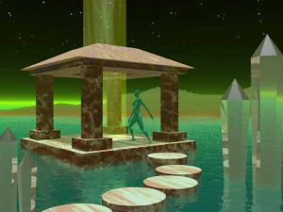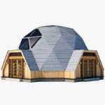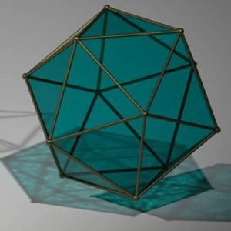
The learning centers are constructed and created by our teachers, practitioners, mentors, masters, interns, volunteers, and students participating in our traditional and non-traditional, home building programs offered at the Structural Design Center.
At the Wholistic Structural Design Center, our teachers share their knowledge and expertise of interior and exterior, Eco-friendly shelter design. Sacred geometry, or other structural, designs are constructed from natural building materials and products indigenous to their communities and geographic location. Our students are instructed in the art of framing, foundations, home maintenance, plumbing, heating, waste management, electricity, and other requirements needed to create and maintain safe and efficient Eco-friendly homes, classrooms and other needs for our learning centers.
Our creations, of Sacred Geometry design, have a profound influence upon our health, psychic and spiritual state of being. Harmony and balance, light and color, relationship to landscape, ecological sympathy, energy efficiency and geometric form are contributing elements of shelters that spiral in nurturing form rather than draining. As humans, we resonate at both the cellular and consciousness levels with nature. We create an environment around us that supports our inner and our outer senses, as we connect in synergy with nature and the universe. The architecture of the buildings, we inhabit, whether they be our home, workplaces, churches, mosques, synagogues, temples, or other healing, learning, or meditation centers, have similar impact upon our senses. It is the architecture of nature that spirals and supports our limitless creative energy. Hidden within the architecture of material existence are the geometric forms, the building blocks, which make life possible as we know it. They are designed to support the passions of those seeking knowledge, or relief from ailments or blockages that affect a person's physical, emotional, intellectual, and spiritual being, received from the healing arts.
Apart from any psychological influences, it is mainly the geometric spaces and the materials of the structures that influence our responses from the biological relationship that occurs at the cellular level and the myriad of components that make up our physicality. This is also a synergistic extension of our Universal Science Center and Self-Healing Center regarding the synergistic and strategic positioning of these permanent and non-permanent, structures. Designs made from natural Eco-friendly products indigenous to the area that serve the needs of our students, teachers, interns, and practitioners in an environment of flow between among the various modalities created by our students and teachers from the Structural Design Center.

Nature Trails & Bike Paths
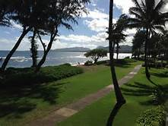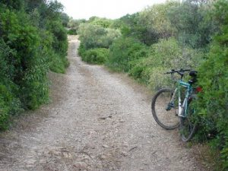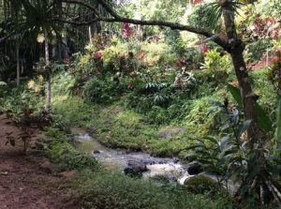
Throughout the land are walking trails and bike paths. We invite you to peacefully stroll, picnic, or bike ride, throughout our community that is maintained by our Landscaping Center. Honor the beauty of the land consisting of fishponds, food forest, animals and other types of flora and fauna.

Interactive Outdoor Playground & Activities Center
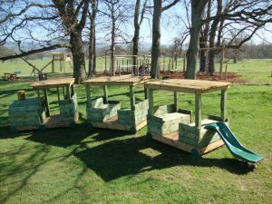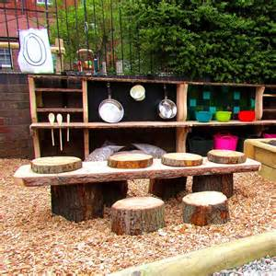
The Interactive Outdoor Learning Playground and Activities Center is designed for play and interactive learning. This is an interactive playground of learning activities honoring the imagination of children and their interactions with each other.
A playground designed with ample space between activities, giving children plenty of room to run from one discovery to the next. An interactive playground, with interactive walls, panels and other activities accessible by ramps, bridges, and transfer stations, that allows everyone to reach the highest deck of equipment. The playground has a sensory garden, with a series of integrated spaces, devoted to the five senses of seeing, hearing, feeling, tasting, and smelling. This barrier-free playground promotes acceptance and compassion, as important values, for children to embrace.
An Interactive playground designed for children with disabilities, allowing them the ability to play right alongside their able-bodied friends and siblings.

Skate-Park Center
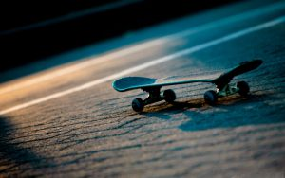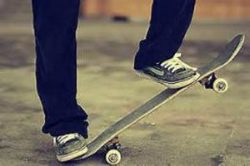
A professional type skate-park created for beginner, intermediate and experienced skateboarders. The skate-park is designed by the children participating in the Structural Design program. Students are offered programs in the maintenance of personal equipment, and the facilities, for long-term usage. Classroom, video, practical training, and safety equipment is offered to those seeking to learn or expand their knowledge and skills of skateboarding.
The skate-park is monitored by mentors and skilled teachers. The skate-park has resting stations, benches, water, picnic tables and restroom facilities to support its users.
Through the creative powers of our students, and teachers, our intention is to work with the professional skateboarding community to host their tournaments, and world championships, as fundraisers, entertainment and learning opportunities for our staff and students to further their knowledge in this activity or sport.
The skate-park theme will embrace and highlight the culture of the area.

Library, Computer & Business Center
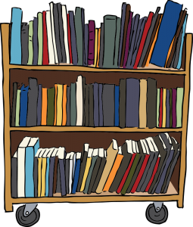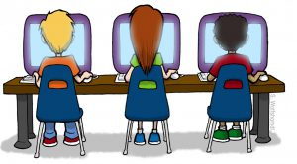
At our Library, Computer and Business Center we offer computer courses and workshops. We offer an internet café, with free Wi-Fi, and desktop computers for those involved in research or for reference. Part of the learning experience here includes programs in website design, basic accounting, and finance; data entry & other office applications for those seeking to expand their knowledge in various applications, or to hone their craft and passions.
Other business or computer courses are available upon request.
We offer programs in marketing to assist the students in generating income to support their needs, and their family, beyond what is provided for at the community.

Research and Development Center
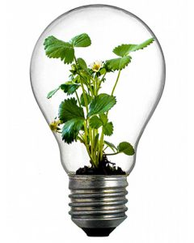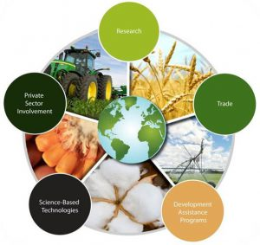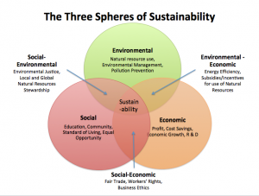
Our teachers, mentors, practitioners, and students are empowered to think 'outside the box' as limitless and endless beings of creation. Seeing problems as opportunities to discover and create natural solutions. Our intention is to discover the limitless and endless potential of natural creation beyond its perceived value or use.
For example, the discovering of nature’s healing medicines, from perceived waste, or from the plants grown at our organic agriculture center. We see in 360-degree view that all of creation is complete unto it and therefore has endless possibilities from which to serve humanity.
We teach, learn, and share in a collaborative environment, with the understanding that each student has a part in the whole. Continually upgrading, sharing, and offering new programs to fit the needs of the individual, and the collective from all walks of life.
The volition of our research is with being in alignment with the values of each Eco-system, throughout the world, as we are all connected in some way.
Research and development is important for all the programs and services offered at each center of learning.
“The time will come when diligent research, over long periods, will bring to light things which now lay hidden. A single lifetime, even though entirely devoted to the sky, would not be enough for the investigation of so vast a subject... And so, this knowledge will be unfolded only through long successive ages. There will come a time when our descendants will be amazed that we did not know things that are so plain to them... Many discoveries are reserved for ages still to come, when memory of us will have been effaced. ― Seneca

Transportation & Maintenance Center
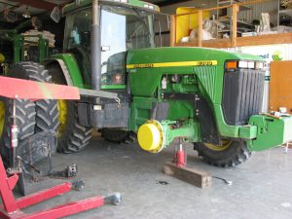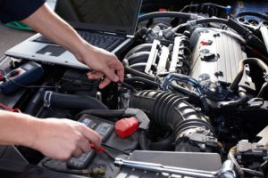
At the Transportation and Maintenance Center, the students are taught methods, practices and procedures for proper installation, maintenance and repair of the equipment and vehicles supporting our learning centers, members, and students.
We offer programs for the maintenance of air, ground and water vehicles, or other vessels, used for the safe livery of food, clothing, shelter, medicine, goods and other services to our local distribution centers or other areas, throughout our worldwide community network. Our vehicles, on occasion, could be called into emergency relief service for countries experiencing disasters due to climate change, war, or other unfortunate circumstances.
We share the values of preventative, and on-going maintenance to lessen downtime of our various products and services. Students learn to repair or maintain tractors, lawn mowers, heavy equipment, weed whackers, chainsaws, hedge trimmers, printers, laptops, desktops, monitors, audio-visual equipment, interactive playground equipment, solar panels, wind turbines, and other types of Electro-Mechanical devices found at our learning centers.
We prepare our students to fill the needs of the island, which could also involve internships or on the job training if needed.

Spiritual Development, Prayer & Meditation Center
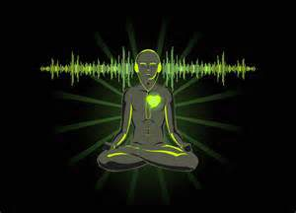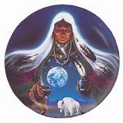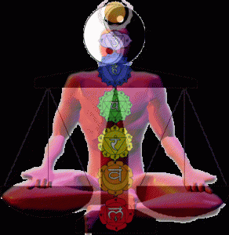
A Spiritual Development, Prayer & Meditation Center is shared with our spiritual leaders, teachers, practitioners, students, and the public. A Spiritual Development, Prayer & Meditation Center that is welcoming of all types of religious beliefs, or practices, serving the greater good of all creation, by connecting with the Source, or God, of many names, through prayer, chanting, dance, meditation, and other spiritual practices. A Spiritual Center that is for the balancing of the physical, emotional, intellectual, and spiritual needs of the individual, group, family, community, island, nation, and world.
A Spiritual Center, in concert with our Self-Healing Center, offering alternative and wholistic body health, guidance and services like yoga, Pilates, sacred dance, breath work, meditation, energy healing, sound healing, spiritual counseling, and more. This, as we continually research the best ways to heal and serve the complete human being, and other forms of life, through the honest communication and pure love of like-minded peaceful people, countries and nations living in unified sustainable life consciousness.
A place where spiritual teachers open pathways and gateways for each individual to discover, and heal themselves one step, one breath and one song at a time.

Sanctuary of Integral Truth, Completeness, & Oneness
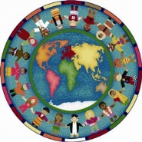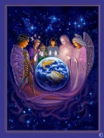
The Sanctuary of Integral Truth, Completeness, and Oneness is a sacred geometry meeting structure consisting of a council of spiritual mentors, teachers, and elders, who work seamlessly together to create and manifest programs that fill the passions and needs of people looking to provide for themselves, or their family, a better quality of life while becoming a positive and contributing influence upon their family, community, island, nation, and world. We are forward-thinking individuals and groups, of many cultures, serving humbly and gratefully in our cooperative and committed volition to world peace, balance, harmony, and abundance, for all. The Time is Now to lay down our weapons of destruction, return home, and share our cultures in honest communication with each other as we pray, learn, play, and dance with our children, family, neighbors, community, state, nation and world.
The Sanctuary of Integral Truth, Completeness, & Oneness, in Unity Consciousness, is a council of individuals grounded in equanimity. An equal number of divine crystal feminine and masculine forms, and energies, committed to sustainable life living, for all, in a world of Peaceful People. Meeting regularly, in honest communication, with our teachers, practitioners, students, interns and others needed to maintain balance, harmony and integrity with all our programs and connections throughout the peaceful portions of our world.
This Sanctuary of Integral Truth, Completeness, & Oneness co-create, with our Future Leaders of tomorrow, serving in a collaborative and synergistic environment. Our primary council members are visible on a daily basis, at our various centers, identifying and working side by side with future leaders. This provides for a seamless transition of roles is maintained when members pass on, retire, or step down for any reason. It is said that “The vision of the unity and goodness of the world is born in our own private and collective intention to transform the way we see things, to honor one another in our struggle for self-actualization, and interpreting it as an adjunct of our own (Thomas Merton).”
The Sanctuary of Truth, Completeness, & Oneness bans war and all weapons of mass destruction that destroys life and our natural resources that serves the greater good of all. We are here to serve each other as equal caregivers of the earth, sky and All That Is. We are beings of peace, unconditional love, understanding, forgiveness and unity with the individual and collective right to life, liberty, and happiness. Governments, religion, and societies cannot exist without people. We believe in the saying Of the People, By the People and For the People and stand strong in that truth as autonomous loving beings, of integrity and limitless potential, in our creation of Sustainable Life living for all. We are open and always discovering ways to enhance our programs of sustainable life practices for all peaceful people, communities, countries, kingdoms, and nations.

World Class Team of Teachers, Masters, Mentors & Practitioners
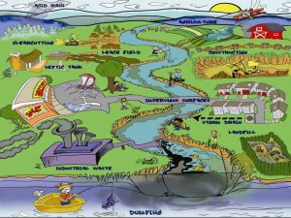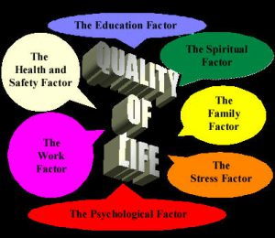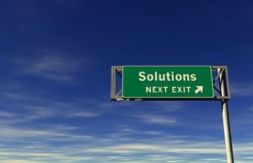
The Sustainable and Regenerative Life Vocational Learning Center consists of a world class team, or groups of teachers, interns, and individuals, residing throughout the peaceful world community, focused, and committed to the ongoing research and development of wholistic sustainable life practices for all creation.
Our peaceful-volition is with growing a world of wholistic sustainable life communities for the global exchange of organic foods, natural medicines, spiritual awareness, cultural teachings and unified prayer or meditation to live in a world of peace, balance, pure love, and harmony with each other for the greater good.
A World of Peaceful People that is truly of the people, by the people and for the people. Peaceful People, and peaceful-people that are here to live and create lasting and diverse communities for our children, young adults and elders based upon wholistic sustainable quality of life practices, values, and morals. This is the model of inter-connected sciences working in balance and harmony with nature, the universe and each other. Harmony, pure love, balance, and gratitude in motion is the formula for a World of Peaceful People.
Learning and sharing, in a collaborative environment, with the understanding that each student has a part in the whole. Continually upgrading, sharing, and offering new programs that help the student embrace the fact that we are limitless giving beings, with limitless opportunities, producing solutions that serve the greater good.
All our teachers, practitioners, mentors, interns, and future leaders gather, at the Sanctuary of Integral Truth, Completeness, & Oneness circle, for the sharing of ideas, opinions, and knowledge to enhance our current program offerings, or to share new services.
The initial group of teachers consisting of professional teachers, tutors, professors, star teachers, masters, shamans, kahunas, future leaders & star elders doing their part in co-creating, and manifesting, a seamless program that serves people from all walks of life, regardless of income, race, color, creed, sex, sexuality, age, health, religion, culture, or belief system.

Donors, Investors & Philanthropists
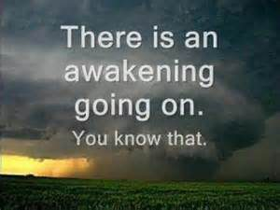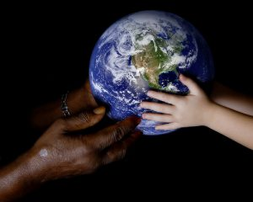
The World of Peaceful People Sustainable and Regenerative Life Vocational Learning Center members do humbly and gratefully ask your support in co-creating a better, safe, and sustainable world for you, your children, the next seven generations and more.
Life is a celebration for all people, and cultures, from all walks and disciplines of life. We look at life from a 360-degree view to ensure that our creations, which may resonate locally, have no negative impact on the Eco or life systems in other parts of the area or world. We are a synergistic group of Peaceful-People that have the willingness to stand behind, and share, our perceptions of truth to discover the whole truth. We stand up for real change and embrace that every person has the sovereign autonomous right, wherewithal and need for healthy food, clothing, shelter, wellness, clean water, healthy air, land, water, and knowledge.
We are sovereign children, and stewards of this gift called Earth that is born from a higher Source, known by many names. As stewards and caregivers of the land, we envision our students, practitioners, interns, and teachers working hand in hand creating a beautiful, and abundant place where anyone can come heal, learn, play, grow and prosper in a safe and beautiful environment filled with a positive vibration of Peace, Unconditional Love, Understanding, Forgiveness, and Unity (PULUFU) in harmony and balance with creation and All That Is.
It is a natural human desire to help others transform, in a loving and nurturing way, into a higher form of consciousness, in humility and gratitude, so as to make a greater impact on serving self, community, island, nation and the world. What we ask each student, in return, is to share their knowledge, perceptions, and imagination with others while living in synergy with all creation.
We are Private Membership Association and not a For-Profit corporation, or a Non-Profit corporation. We are co-creating a community of trust, integrity and honor as caregivers, and partnerships, with all creation through our individual membership programs, and like-consciousness associations or groups.
This is a discovery of who and where we are today, in this evolution of our species, as crystal human beings of equanimity in spirit, energy, light and pure love.
We are also seeking donors who embrace the gift of giving from their heart, mind, soul and being as their primary intention, and not simply as a tax right-off. We reach out, with our heart-soul center, to those of means that have the wherewithal and heartfelt intention to be an integral part of the change to a world of peace. A World in which humanity can be their dreams, live their passions, and discover their true happiness in a life of peace and love for all creation.
We are simply offering, and maintaining, a donation funded wholistic sustainable vocational learning, healing and spiritual community that serves the needs and inherent rights of all people in concert with all creation. A free wholistic, sustainable, vocational, learning, healing and spiritual center built upon a strong foundation of peace, balance, harmony, and love for each other.
We are guided by a unified compass, of morals and values that create quality in all phases of life. We are complete individuals, and collectives, here to serve our Creator of many names, ourselves, family, community, island, nation, and the world, in this evolution of our species. At the same time, we are creating a potential workforce of people, passionate in what they do, for the island and the world in our seamless transition from war to peace.
As a potential member and/or donor, we are humbly and gratefully asking you to open up your heart of hearts to assist us in the ongoing development, support, and creation of this wholistic vocational learning, self-healing, and spiritual center community as we do our part in the whole by creating and offering this vision one step, one breath, one song, one project, one program and one dream at a time.

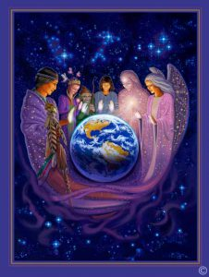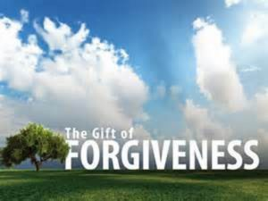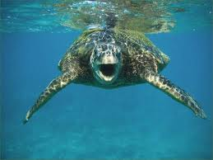

Needs - Wholistic Sustainable Life Vocational Learning, Healing, & Spiritual Center
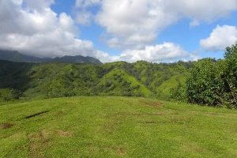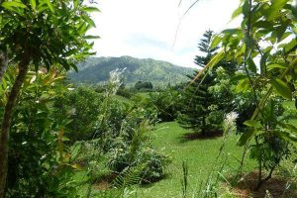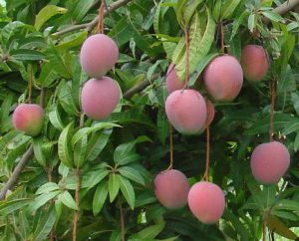
Our immediate need is a long-term lease, purchase, or donation of at least one hundred and forty-four (144) acres of agricultural land, with natural streams, water and mature fruit trees in a convenient and accessible Kauai location.
Our vision is with the ongoing development of this Wholistic Sustainable Life Vocational Learning, Self-Healing, and Spiritual Center as outlined. Co-creating this and future centers one step, one breath, one song, one project, one program and one dream at a time. Blessed and gifted with the proper tools necessary for meeting the needs, and the honoring of all our programs, teachers, mentors, practitioners, interns, healers, students, and those who honor us with their heart-center donations.
Kauai is the catalyst for world peace. This donated piece of land is a sustainable life model consisting of a peaceful world of people, and nations. people and nations living, learning, creating, and teaching in balance with the Universe and Nature. Honoring the alchemy of the Air, the Land, the Water, and the Fire along with the Birds, the Animals, the Fish, the Fowl, the Creepy Crawlers, and righteous people in our connection with All That Is!
We are NOT a for-profit or non-profit world community. We prefer gifts, and donations that serve and support all our programs, the maintenance of the learning centers and the upkeep of our equipment and land. Donations of money are accepted, when no other options are available, to support the services, or items, needed to maintain our learning centers. We share with our students a mindset of bartering for services, or receiving heartfelt donations, as ways to fulfill our needs, without the use of money. Monies received are immediately appropriated to purchase a priority item of need that supports any, or all, of our centers.
With your donations, grants, and contributions, we can properly maintain our vocational learning, health, and meditation centers by having the right tools, equipment and inventory on hand that keeps us in synergistic flow with the services provided and to fill the needs of our students and staff.
We seek donations of heavy farm equipment and machinery for mowing, planting, clearing, and landscaping are primary needs to maintain and develop our centers of learning, healing and spirit. Also, handicapped vehicles are needed to transport our elderly, or physically handicapped, participants and our remote students. Other helpful needs are musical instruments, art supplies, starts for planting, natural birth supplies, elder care supplies, culinary tools, garden tools, telescopes, books, and so on to enhance the learning experience of all our learning centers.

We ask you, you, you, and you to be, and do, your part in this circle of life that is riding the tsunami wave of change in this New Age of Balance and Harmony with all creation. The Time Is Now to move away from the limited belief systems handed down to us. Be the change and awaken to this new earth and paradigm unfolding.
We simply need to stop talking about change and start putting our words into focused abundant action. Be an active member, in evolution to higher unified consciousness and equanimity between the masculine and feminine life-forces. We are the ones we have been waiting for! ‘Be the change’!

Closing Remarks
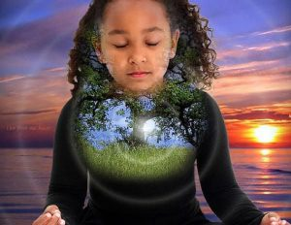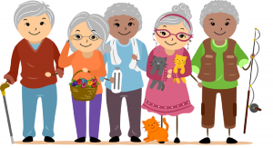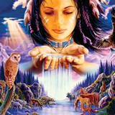
Humanity in Harmony lives in the hearts of all creation. As an extension to our learning centers, we develop synergistic relationships with various like-minded groups to achieve our long-term goal as a strategic natural food, medicine, and spiritual island that benefits people here and throughout the world. Our vision is creating similar wholistic sustainable life schools, and communities, all over the world. Peaceful people creating a network of cooperative super consciousness beings, and nations, committed to powerful synergistic change throughout the world community creating a positive effect upon all creation. A living example of sustainable life practices of feeding, healing and empowering individuals, communities, nations throughout the world. One whose intention is with the ending of separation, among the people, that is created by war, greed, materialism, fear, and doubt, to name a few.
What's the source of your thoughts regarding your purpose? Is it a sense of purpose, which is the highest attribute of a fully functioning person? The very act of questioning why is an indication that your thoughts are nudging you to reconnect to your field of intention, find your passion and nurture it. Your inner being knows why you are here, but your ego prods you to chase after money, prestige, popularity, and sensory pleasures and miss the purpose of living. The time has come to reclaim our sovereign selves, and discover the truth of who we are, in this metamorphosis of our species, in this Golden Age unfolding.
In his book, The Hero with a Thousand Faces, Joseph Campbell wrote “The aim is not to see, but to realize that one is that essence; then one is free to wander as that essence in the world. Furthermore, the world too is of that essence. The essence of oneself and the essence of the world: these two are one. Hence separateness, or withdrawal, is no longer necessary. Wherever the hero may wander, whatever he may do, he is ever in the presence of his own essence, for he has the perfected eye to see.
Commit to living in a sovereign world, where ALL ARE WELCOME! A place where we empower ourselves to become sovereign limitless beings connected to All That Is.
The World of Peaceful People Sustainable Life Vocational Learning, Self-Healing and Spiritual Center offer you a path to find, and grow your sovereign self, at your own pace. We offer you knowledge to serve your own passions in life and become a contributing member to your family, community, island, nation, kingdom, and world.
We didn’t ask for this stage of war, lies, deception and separation, or this music of oppression, control, greed, lust, hate and anger. We were manipulated and controlled to live this way. We were invited to this stage, to hear this music of misinformation and lies that has dis-empowered us as people. Awaken! We are sovereign. We can make a difference! Stand in your truth with integrity and understanding. Discover your passion(s), gifts, and purpose in life. We are all equal, yet unique in our DNA.
We are not hypocrites in life as we live what we share with others. Personal choice is always yours in life as to the direction you choose to go. We are here, as caregivers of this Earth, let us create a new stage, and a new song. Because we are here, let’s dance. Let us dance to a new paradigm and co-create a better world. Let us co-create, as equals, a World of Peaceful People and peaceful people living in balance and harmony with all creation. A co-creation filled with peaceful people co-creating a new moral compass for the children of yesterday, today, and tomorrow! A direction, and a purpose, filled with solutions that provide an abundant sustainable life for all, not just the few! Be the change! We are not matriarchal or patriarchal as each of those systems is of separation. We ‘Get It’ that we are all part of the solution so we are careful not to use words of separation.
Few people have the courage of their convictions to really do what must be done, in a selfless manner, to risk it all for the sake of righteousness and love. To counteract the blind destructive nature of war and aggression, the Cosmic spiritual force evolves itself through those souls who seek transcendence from conflict altogether.
We are a world community of peaceful-people and nations who truly stand for world peace and the end of separation among people, government, religions, and society. We didn’t ask for this stage of war, lies, deception and separation, or this music of oppression, control, greed, lust, hate and anger. We were manipulated and controlled to live this way. We were invited to this stage, to hear this music of misinformation and lies that has dis-empowered us as people.
Awaken! We are sovereign. We can make a difference! Stand in your truth with integrity and understanding. Discover your passion(s), gifts and purpose in life. We are all equal, yet unique in our DNA. We are not hypocrites in life as we live what we share with others. Personal choice is always yours in life as to the direction you choose to go.
Few people have the courage of their convictions to really do what must be done, in a selfless manner, to risk it all for the sake of righteousness and love. To counteract the blind destructive nature of war and aggression, the Cosmic spiritual force evolves itself through those souls who seek transcendence from conflict altogether. We are a world community of peaceful-people and nations who truly stand for world peace and the end of separation among people, government, religions, and society.
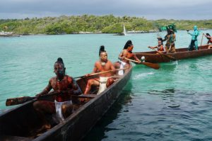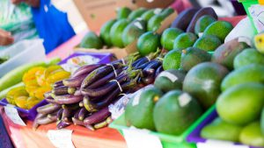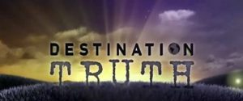

Service Opportunities - Teachers, Mentors, Masters, Interns, & more.
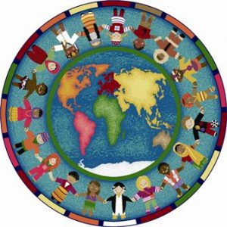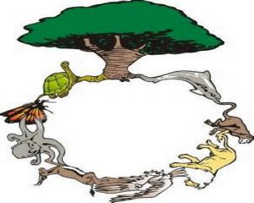
Our peaceful-volition is synergistically serving, and co-creating, with the most peaceful, passionate, loving, and qualified giving teachers, in highest consciousness, of this New Earth. Teachers, practitioners, and mentors who are truly in alignment with World Peace and the acceptance of all cultures, of peaceful people, and nations in shared values. New Age Masters of the Arts and Sciences in a cooperative learning experience that is here to ‘Be The Change’.
A counsel of men and women, equal in number and each with their unique DNA, serving creation as equals for the greater good of all. Co-creating, and living, in a zone of Peaceful People.
We are opening our doors, and our hearts, to meeting with qualified like-minded teachers, educators, professionals, interns, and mentors to co-create and implement this vision. We need beings of limitless solutions who are interested in sharing their passions & gifts, locally and globally, as we co-create learning centers and communities of wholistic sustainable life living here in Kauai, and worldwide. An honest community of loving, nurturing, peaceful, and care-giving people doing their part in co-creating world peace, unity, balance, and harmony with all creation.
We humbly and gratefully invite you to come and break bread with us. Share your passions, and dreams, about the knowledge, wisdom, and understandings that you bring to the table for co-creating and being an integral part of this Wholistic, Sustainable Life, Vocational, Learning, Self-Healing and Spiritual Center. Co-creating in a World of Peaceful-Nations and Peaceful-People.
We are a global model of the Hawaiian system of sustainability. Our headquarters is located in Kauai. We see Kauai as the catalyst for World Peace. We live in Aloha and wish to share this feeling of love with the world. Kauai is also referred to as the Garden Island and in some references as the Garden of Eden where it all began.
It is with great humility and gratitude that we dedicate our life to filling our garden with Sustainable life practices and services, in righteous intention, during this evolution of our species to highest consciousness in a world of peace.

Bookkeeping – Accounting
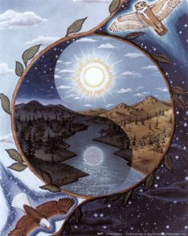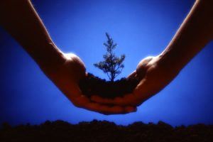
The Bookkeeping & Accounting process is managed by the spiritual council of integrity (with interns), located at the Sanctuary of Integral Truth, Completeness, & Oneness.
Regardless of the type of donations received (money, equipment, etc.), the donations will immediately be applied to fill the greatest needs, of the center, after each 28-day period. There is no financial, or resource, carry over to the next month.
Our financial year is from July 26 - July 25, or thirteen (13) twenty-eight (28) day periods. Our books are open for all members or donors to see. Teachers receive free housing that is built, in Sacred Geometry form, by the students of the Structural Design Center. The teachers also receive food, clothing, self-healing modalities, and knowledge from our other centers worldwide.
Exchange programs, for teachers, are available as new centers come online worldwide.

Contact Information – World of Peaceful-People
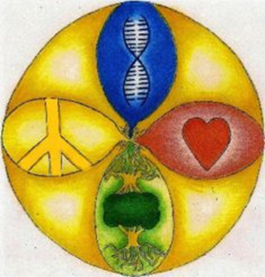

World of Peaceful-People
Attention :Megeso-William-Alan: Denis

Call Center & Suicide Prevention Hotline
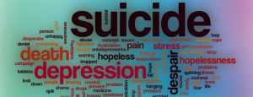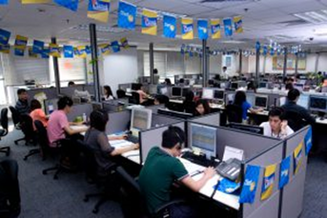
The World of Peaceful People call center serves the following functions:
- Telemarketing
- Donation processing
- Suicide Helpline
- Dispatch
- Telethons
- Answering Service
- General Purpose
Main Job Duties and Responsibilities
- Provide customer service on company-supported computer applications and platforms.
- Troubleshoot problems and advise on the appropriate action.
- respond to requests for technical assistance in person, via phone, chat or email
- diagnose and resolve technical hardware and software issues
- research questions using available information resources
- advise user on appropriate action
- follow standard help desk procedures
- log all help desk interactions
- administer help desk software
- follow up with customers and users to ensure complete resolution of issues
- redirect problems to correct resource
- identify and escalate situations requiring urgent attention
- track and route problems and requests and document resolutions
- resolve technical problems with Local Area Networks and Wide Area networks
- prepare activity reports
- inform management of recurring problems
- stay current with system information, changes and updates
- help update training manuals for new and revised software and hardware
- train computer users as necessary
- clean up computers

GED - General Education Degree
Project-Based Learning
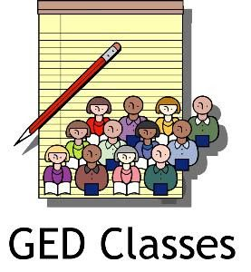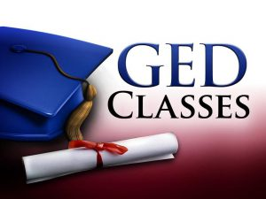

Trade Distribution Center
Import – Export
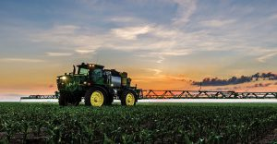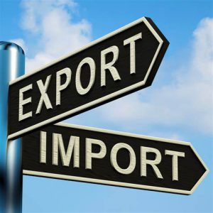

Ibogaine Medical
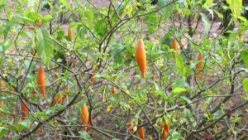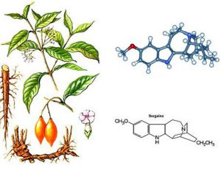
Ibogaine Treatment Center
- Professional treatment – At the end of the day the most important part of your journey to recovery is the Ibogaine treatment itself. We have professional licensed medical staff including doctors and nurses on hand to make sure you have a safe experience during your Ibogaine therapy and treatment. Having someone there to monitor you is imperative.

- Pre-treatment and post-treatment counseling – This includes a list of drugs and foods that must be avoided, as well as time-frames for avoiding them, so that the Ibogaine treatment can be as strong and as effective as it needs to be. The treatment itself is the most important part, however preparing properly for the treatment is extremely important in ensuring a successful overall treatment experience.

